- List all products along with their category names.
Ans:
select P.Name ,C.CategoryName from products P
inner join Categories C
on P.CategoryID=C.CategoryID;

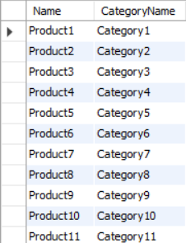

- Show the orders with customer names and order dates.
Ans:
select o.orderId,c.Name,o.OrderDate
from orders o
inner join Customers c
on o.CustomerID=c.CustomerID;
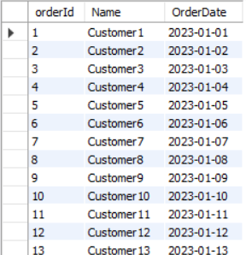

- Display all order details with product names and quantities.
Ans:
select o.DetailID,o.orderID,o.ProductID,o.quantity,P.Name,p.StockQuantity from orderdetails o
inner join products p
on o.productID=p.productID;
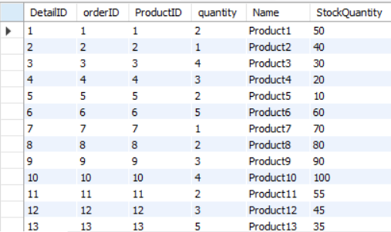

4) Find all customers who have placed an order (with their order IDs).
Ans:
select c.Name ,o.OrderID from customers c
inner join orders o
on c.CustomerID=o.CustomerID;
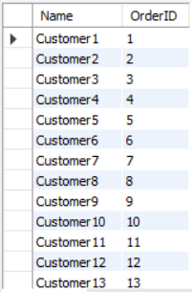

5) List all reviews with product names and customer names.
Ans:
select r.ReviewID,r.Rating,r.Comment,p.Name,c.Name from reviews r
inner join products p
on r.productID=p.productID
inner join customers c
on r.CustomerID=c.customerID ;
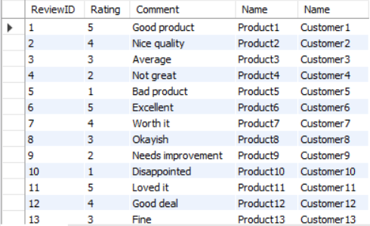

6) Show products with their discounts (if any).
Ans:
select p.name,d.DiscountAmount from products p
left join discounts d
on p.productID=d.productID;
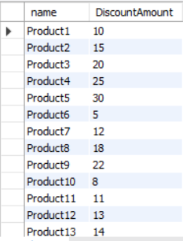

7) Find all orders along with their shipping details (ship date & delivery date).
Ans:
select o.orderID,s.shipdate,s.deliverydate from orders o
left join shipping s
on o.orderID=s.orderID;
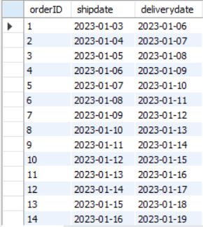

8)Display customers who reviewed a product but never ordered it.
Ans:
select c.name,r.productID,r.Rating,r.Comment from customers c
inner join reviews r
on c.customerID=r.customerID
where c.customerId not in (select o.orderID from orders o);
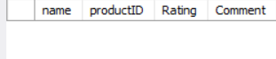
9) List all products that appear in order details but do not have any discount.
Ans:
select p.name from products p
inner join orderdetails o
on p.productID=o.productID
where p.productID not in (select d.productID from discounts d );
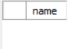

10) Find customers who placed multiple orders.
Ans:
select c.name from customers c
inner join orders o
on c.customerID=o.customerID
GROUP BY c.CustomerID, c.Name
HAVING COUNT(o.OrderID) > 1;
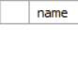
11)Show the products with their stock quantity and total ordered quantity.
Ans:
select p.Name,p.stockQuantity,sum(o.Quantity) from products p
inner join orderdetails o
on p.ProductID=o.ProductID
group by p.productID,p.Name,p.stockQuantity;
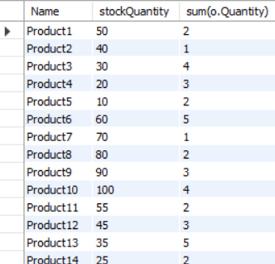

12) Find all orders where the shipping delivery date is later than 7 days after the order date.
Ans:
select o.orderID from orders o
inner join shipping s
on o.OrderID=s.OrderID
where s.DeliveryDate >o.OrderDate + INTERVAL 7 DAY;
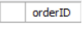
13) Show all reviews with customer names and product categories.
Ans:
select r.ReviewID,r.Rating,c.name from reviews r
inner join customers c
on r.CustomerID=c.CustomerID
inner join products p
on r.ProductID=p.ProductID
inner join categories ca
on p.CategoryID=ca.CategoryID;
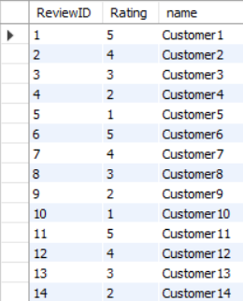

14) Find the total number of orders placed by each customer.
Ans:
select c.name,c.CustomerID,count(o.CustomerID) from customers c
left join orders o
on c.CustomerID=o.CustomerID
group by c.CustomerID,c.name;
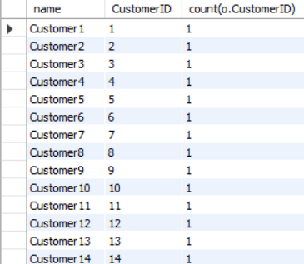

15)Display customers who ordered products from more than 1 category.
Ans:
select c.name,c.CustomerID from customers c
inner join orders o
on c.CustomerID=o.CustomerID
inner join orderdetails R
on o.OrderID=r.OrderID
inner join products p
on r.ProductID=p.ProductID
inner join categories ca
on p.CategoryID=ca.CategoryID
group by c.CustomerID,c.name
having count(DISTINCT ca.CategoryID)>1;
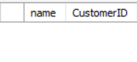

16) Find orders that contain discounted products.
Ans:
select o.OrderID,p.name,d.DiscountAmount from orderdetails o
inner join products p
on o.ProductID=p.ProductID
inner join discounts d
on p.ProductID=d.ProductID;
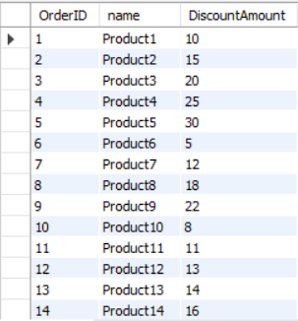

17)List the customers and the products they ordered, including quantity.
Ans:
select c.name,p.name,d.Quantity from customers c
inner join orders o
on c.CustomerID=o.CustomerID
inner join orderdetails d
on o.OrderID=d.OrderID
inner join products p
on d.ProductID=p.ProductID;
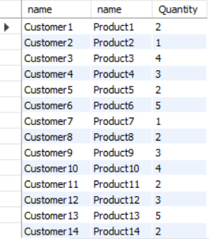

18) Show the highest rated product (with average rating) and its category.
Ans:
SELECT p.Name AS ProductName,c.CategoryName,AVG(r.Rating) AS AvgRating FROM products p
INNER JOIN categories c
ON p.CategoryID = c.CategoryID
INNER JOIN reviews r
ON p.ProductID = r.ProductID
GROUP BY p.ProductID, p.Name, c.CategoryName
ORDER BY AvgRating DESC
LIMIT 1;
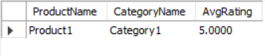

19) Find customers who placed an order but did not leave any review.
Ans:
select c.name from customers c
left join orders o
on c.customerID = o.customerID
left join reviews r
on o.CustomerID = r.CustomerID
where r.customerID is null;
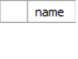

20) List all products never ordered by any customer.
Ans:
select p.productID,p.name from products p
left join orderdetails o
on p.ProductID = o.ProductID
where o.ProductID is null;
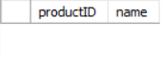

21)Find the most expensive product in each category.
Ans:
select p.name,p.price from products p
where price = (select max(p2.price) from products p2 where p.CategoryID=p2.CategoryID);
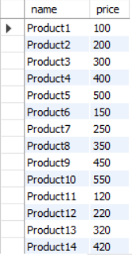

22) Display customers who ordered the cheapest product.
Ans:
select c.name from customers c
where c.customerID in(
select o.customerID from orders o
where o.orderID in (
select d.orderID from orderdetails d
where d.productID in (
select p.productID from products p
where price=(select min(p.price) from products p))));
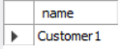

23)Find the product(s) with the maximum discount.
Ans:
select p.Name from products p
where p.productID in (
select d.productID from discounts d
where d.discountAmount =(
select max(d.DiscountAmount) from discounts));
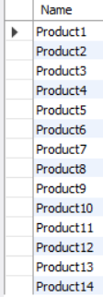

24)List customers who have not placed any order.
Ans:
select c.name from customers c
where c.customerID not in (
select o.customerID from orders o
);
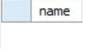

25)Show all products whose price is higher than the average product price.
Ans:
select name from products
where price > (select avg(price)from products);
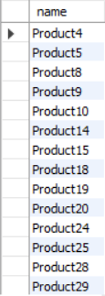

26)Find customers who placed more than 3 orders.
Ans:
select c.name from customers c
where 3 < (
select count(*) from orders o
where c.customerID=o.customerID
);
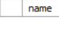

27)Display products that received a rating higher than the average rating of all products.
Ans:
select p.name from products p
where p.productID in (
select r.productID from reviews r
where r.Rating >(select avg(r2.rating) from reviews r2 )
);
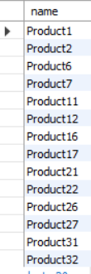

28)Find customers who ordered all products from Category 1.
Ans:
select c.name from customers c
where CustomerID in (
select o.CustomerID from orders o
where o.orderID in (
select d.OrderID from orderdetails d
where d.ProductID in (
select p.ProductID from products p
where p.CategoryID =1)));
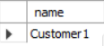

29) Show products whose stock quantity is less than the total quantity ordered.
Ans:
select p.Name from products p
where stockQuantity < (select sum(o.Quantity) from orderdetails o
where p.productID = o.ProductID);
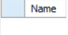

30 )List customers who ordered at least one product but never received a discount.
Ans:
select c.name from customers c
where CustomerID in (
select o.customerID from orders o
where o.orderID in (
select d.orderID from orderdetails d
where d.productID not in (
select ProductID from discounts i
where DiscountAmount is not Null)));
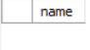

31)Find orders that contain more than 3 products.
Ans:
select o.OrderID from orders o
where o.OrderID in (
select d.OrderID from orderdetails d
group by d.OrderID
having count(d.ProductID) > 3);
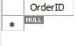

32) Show customers who have placed an order but their shipping has not been done yet.
Ans:
select c.Name from customers c
where c.customerID in (
select o.customerID from orders o
where o.orderID not in (
select s.orderID from shipping s where s.ShipDate is not NULL) );
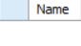

33)Find the first product with the lowest average rating.
Ans:
SELECT p.Name
FROM products p
WHERE p.ProductID = (
select r.ProductID from reviews r
group by r.productID
order by avg(r.rating) asc
limit 1
);
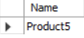

34)Display customers who gave the maximum rating to any product.
Ans:
select c.name from customers c
where c.CustomerID in (
select r.CustomerID from reviews r
where r.Rating =(
select max(r2.Rating) from reviews r2));
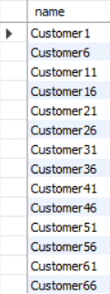
35) Find all orders where the order total (price × quantity − discount) exceeds 10,000.
Ans:
select o.orderID from Orders o
where o.orderID in (
select s.orderID from orderdetails s
inner join products p
on s.ProductID=p.ProductID
left join discounts d
on p.ProductID=d.ProductID
group by s.OrderID
having sum((p.Price * s.Quantity)-d.DiscountAmount) >10000
);
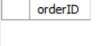

36)Find the product with the highest price.
Ans:
select p.name from products p
where p.price =(select max(p2.price) from products p2);
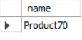

37)List customers who have never placed an order.
Ans:
select c.Name from customers c
where c.CustomerID in (select o.customerID from orders o where o.orderID is null );
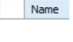

38) Find products that are cheaper than the average product price.
select p.name from products p
where price < (select avg(p2.price) from products p2);
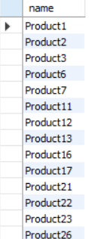

39)List products that have never been ordered.
Ans:
select p.Name from products p
where p.ProductID not in ( select o.ProductID from orderdetails o );
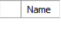

40) Find the orders placed on the latest order date.
Ans:
select o.OrderID from orders o where o.orderDate =(
select MAX(o2.OrderDate) from orders o2);
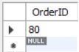

41) String To Date
Ans:
select str_to_date('22-JULY-2025','%d-%M-%Y') as C;
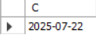

42)Find the lowest stock product
Ans:
SELECT ProductID, Name, StockQuantity
FROM Products
ORDER BY StockQuantity ASC
LIMIT 1;
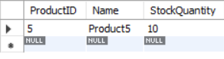

43)Find the top 3 selling products
Ans:
SELECT ProductID, SUM(Quantity) AS TotalSold
FROM OrderDetails
GROUP BY ProductID
ORDER BY TotalSold DESC
LIMIT 3;
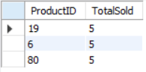

44) Print current date and order date
Ans:
select current_date(),o.OrderDate from orders o ;
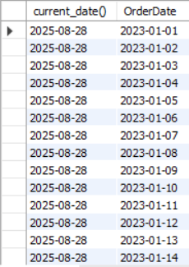

45)Find the minimum stock quantity among products.
Ans:
select p.productID,p.StockQuantity from products p
group by p.productID
order by p.StockQuantity asc
limit 1
;
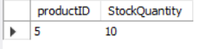

46) Display the total sales amount (Price × Quantity) from OrderDetails.
Ans:
select sum(p.price*o.Quantity) as totalsales from orderDetails o
inner join products p
on o.ProductID=p.ProductID;
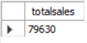

47)Find the total number of products
Ans:
SELECT COUNT(*) AS TotalProducts
FROM Products;
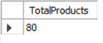

48)Count how many products have price greater than 500.
Ans:
select ProductID,Price from products
where price >500;
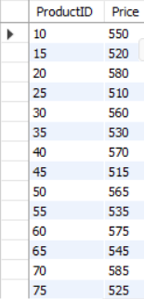

49) Show the earliest order date from Orders table.
Ans:
select max(orderdate) from orders;
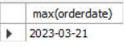

50) Show top 5 most expensive products.
Ans:
select productID,price from products
order by price desc
limit 5;
